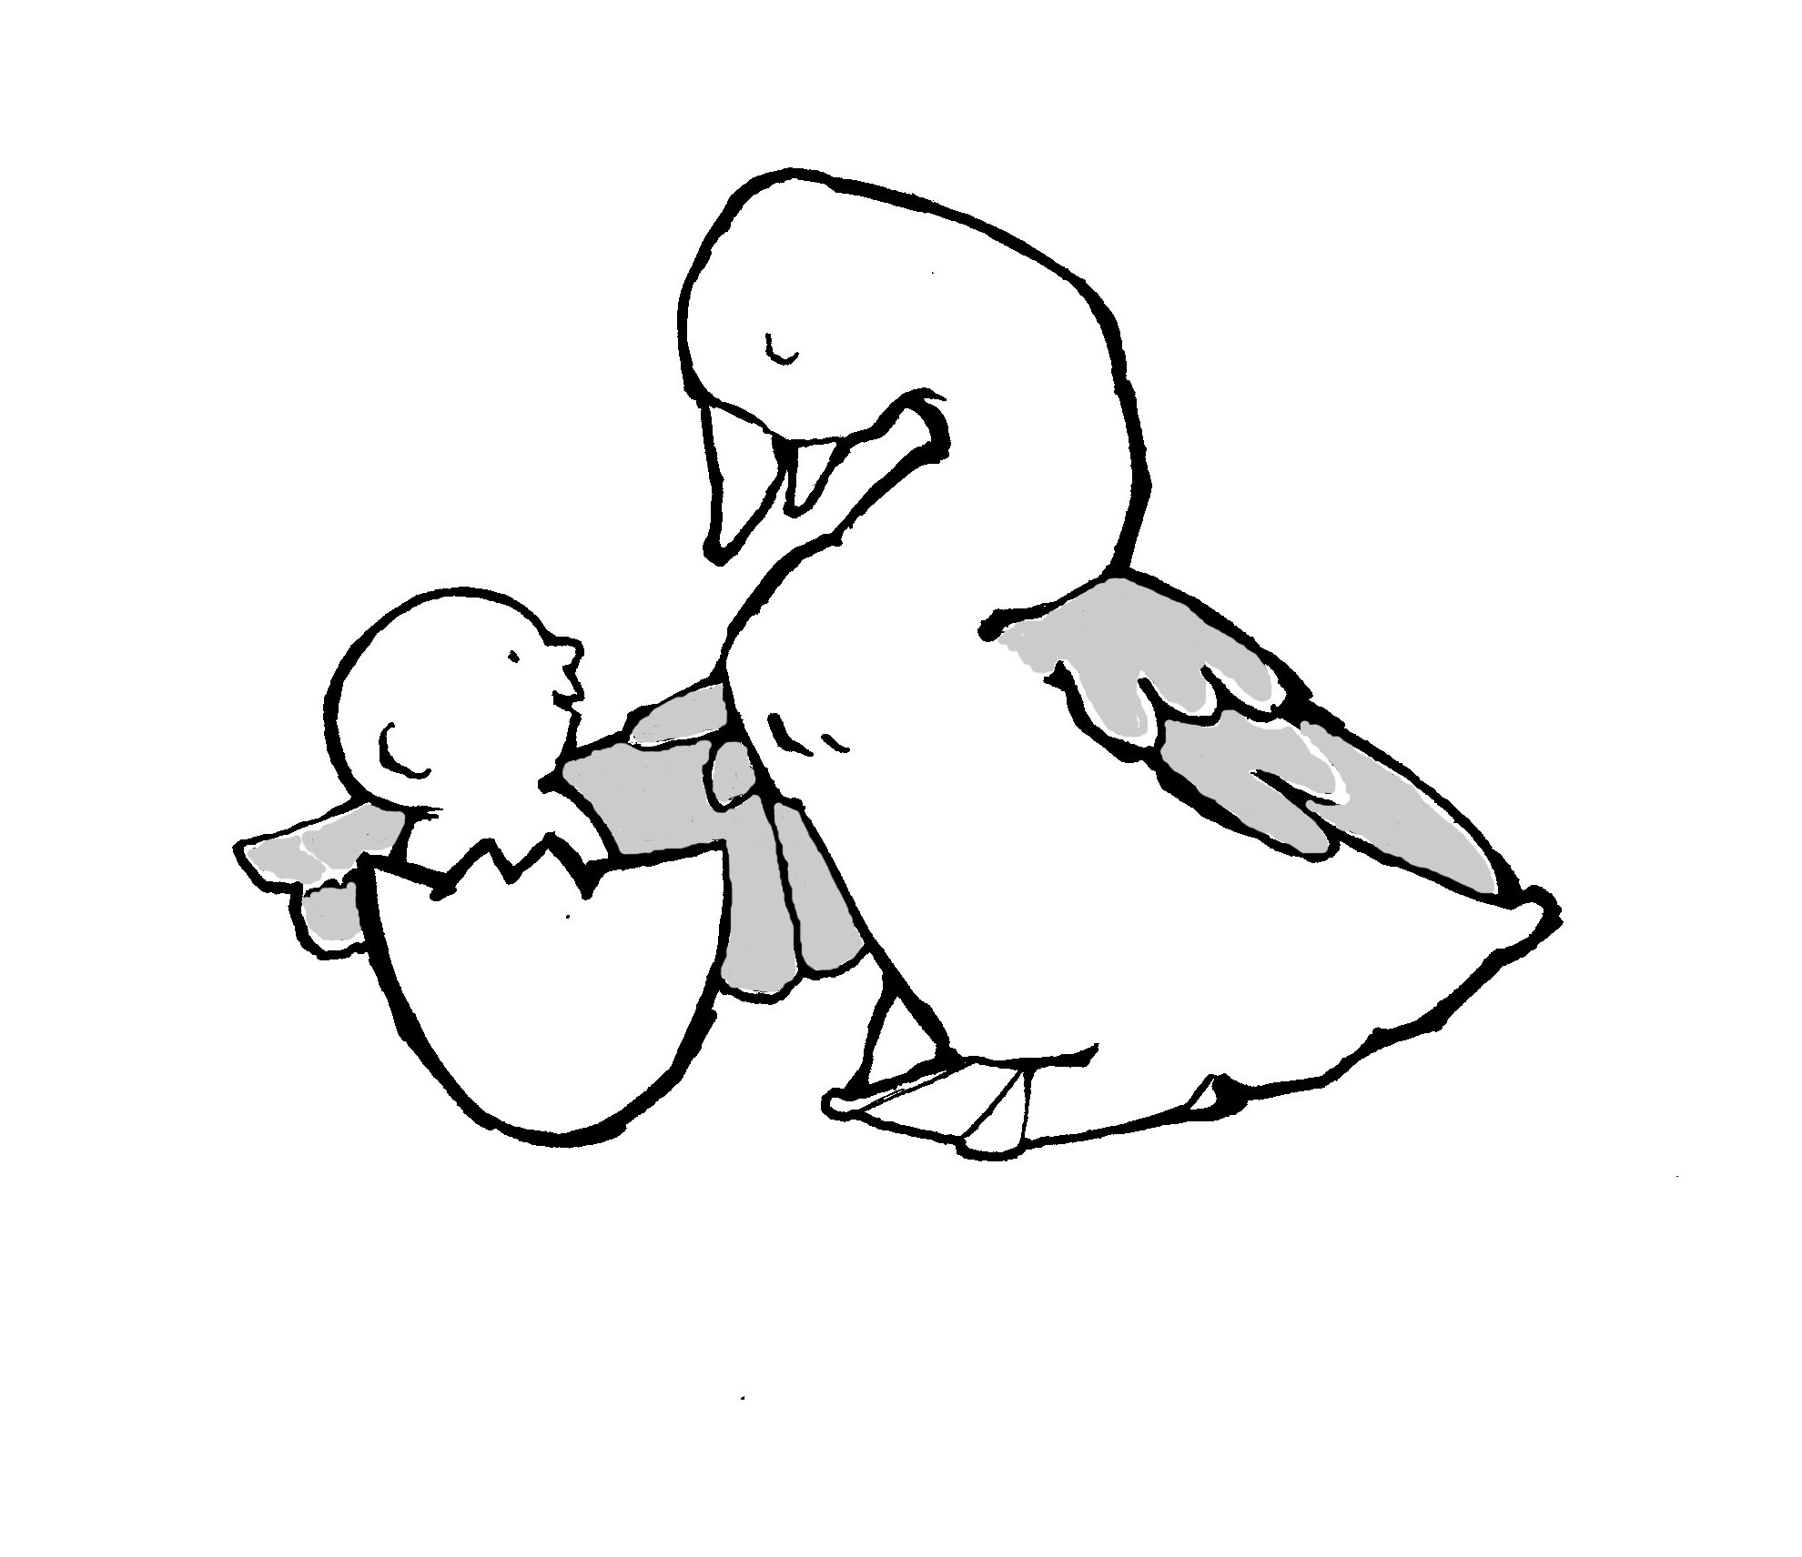
Parent-Child Mother Goose Program®
Programme la Mère l’Oie pour parents et enfants®

PROGRAM REGISTRATION FORM

To reduce paper and postage we ask that you email this form to: info@nationalpcmgp.ca Just save your completed form to your computer in Word format and attach to an email with subject heading: Program Registration Form.
You may also mail the form to: Parent-Child Mother Goose Program® 720 Bathurst Street, Suite 500A, Toronto, ON M5S 2R4 Tel: 416.588.5234 Fax: 416.588.1355 Other forms and information may be found at our website at: http://nationalpcmgp.ca/

Agency/Organisation Name

Mailing Address

City/Town | Province | Postal Code
Phone | Fax | E Mail
Contact person(s)

Program Teachers:

This program will be offered in partnership with another organisation. Yes No
Name(s)
The agency/organisation has paid their annual $40 membership fee: Yes No Not Sure
Membership information & forms are on our website at: http://nationalpcmgp.ca/get-involved/memberships/

Welcome to the Parent-Child Mother Goose Program family. We wish you well and look forward to receiving your reports.

