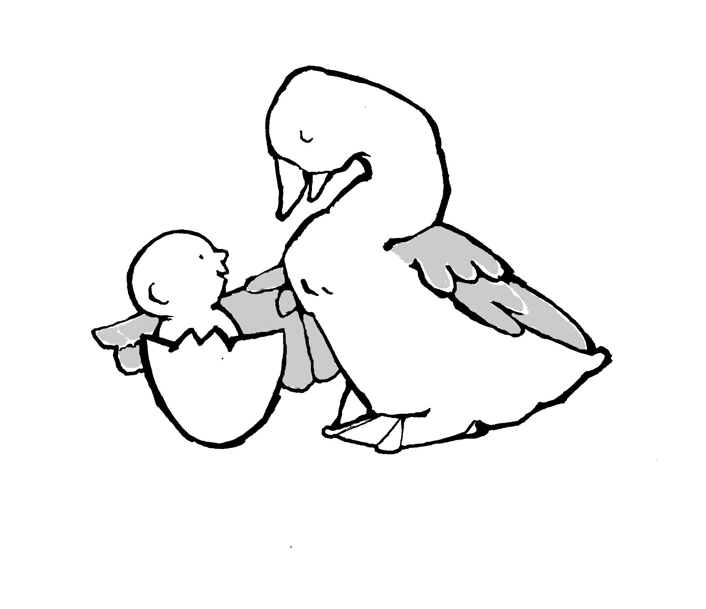
Parent-Child Mother Goose Program®
Programme la Mère l”Oie pour parents et enfants®

To reduce paper and postage we ask that you email this form to: info@nationalpcmgp.ca Just save your completed form to your computer in Word format and attach to an email with subject heading: Certification Registration Form.
You may also mail the form to: Parent-Child Mother Goose Program® 720 Bathurst Street, Suite 500A, Toronto, ON M5S 2R4 Tel: 416.588.5234 Fax: 416.588.1355 Other forms and information may be found at our website at: http://nationalpcmgp.ca/

Teacher Certification Registration Form

Welcome! Please send this information to us at the office to help us keep up-to-date and to assist us in planning for your professional development and certification. Thank you.

Agency/Organisation Name

Mailing Address

City/Town | Province | Postal Code
Phone | Fax | E Mail
Contact person(s)

This organisation is a member in good standing for this calendar year Yes No
This organisation has been sending program reports to the National Office Yes No

For Self-Evaluation Registration, please fill out the section below
For more information, please refer to the Training and Certification section of our website by clicking here or by contacting info@nationalpcmgp.ca with any questions you may have regarding full certification.

Self-Evaluation Registration

Name of Self-Evaluation Teacher

Name(s) of Co-teacher(s)

Date of this registration form Date of Teacher Training Workshop

