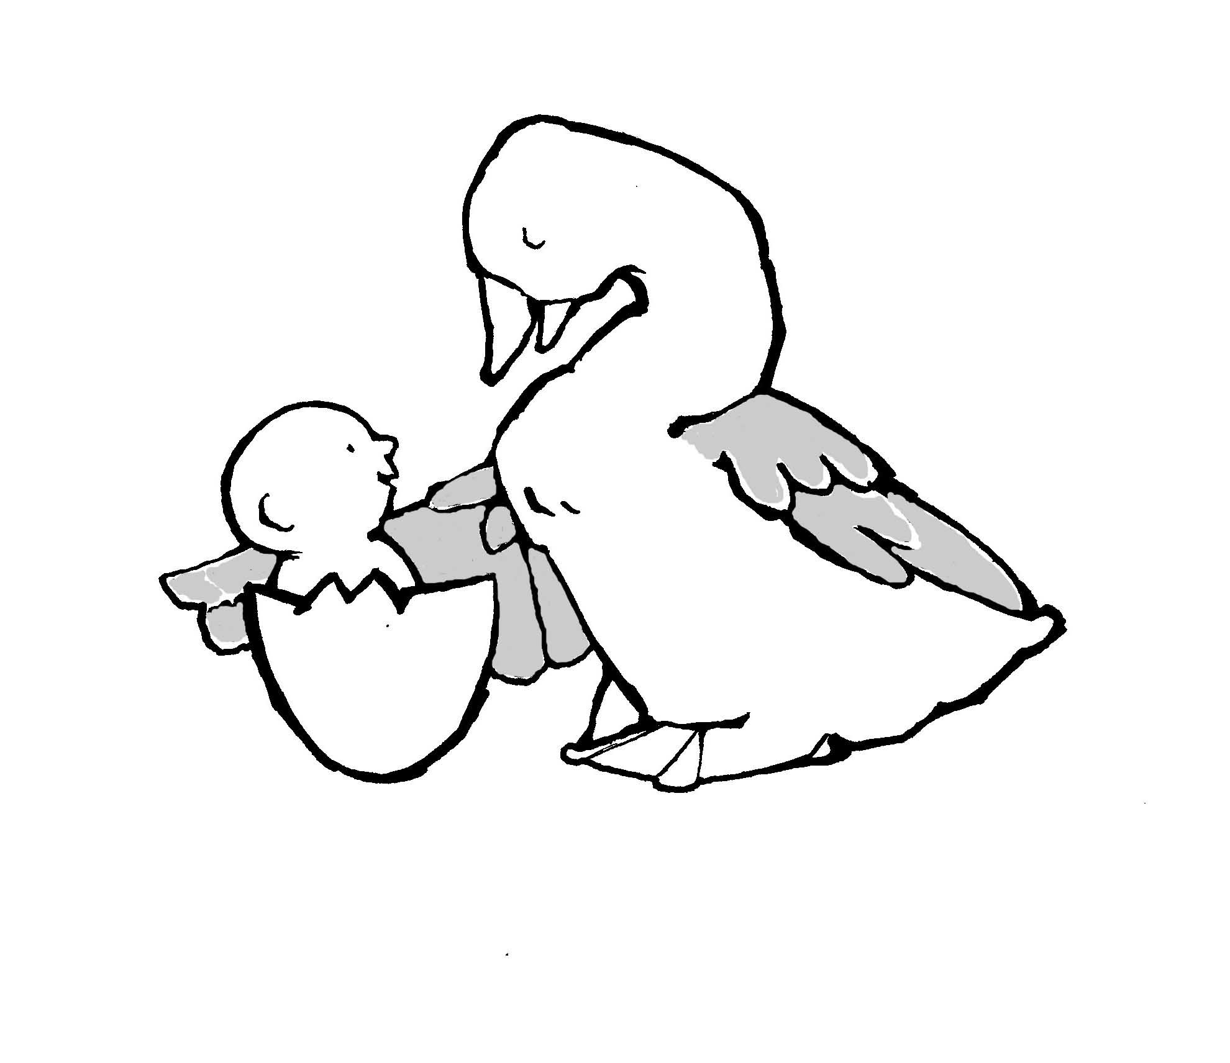
Parent-Child Mother Goose Program®
Programme la Mère l”Oie pour parents et enfants®
Teacher Self-Evaluation Form
SheetThis evaluation form should be completed and sent to the National Office after each ten-session term. To reduce paper and postage we ask that you email this form to: info@nationalpcmgp.ca Just save your completed form to your computer in Word format and attach to an email with subject heading: Teacher Self-Evaluation. You may also mail the evaluation to: Parent-Child Mother Goose

Program® 720 Bathurst Street, Suite 500A, Toronto, ON M5S 2R4 Tel: 416.588.5234 Fax: 416.588.1355. Other forms and information may be found at our website at: http://nationalpcmgp.ca/

Note: Learning about the program and how to teach it is an ongoing process. We expect that in the first few terms of teaching a Parent-Child Mother Goose Program® that you will have some areas in which you are achieving Program standards consistently and others in which you are having difficulty. Please evaluate yourself honestly and carefully, and comment on each area below. It can be helpful to talk with and get feedback from your co-teacher. Send your Program reports for each term along with the Self-Evaluation form. Note: In this form, the feminine pronoun is meant to include the masculine pronoun, as well.

Your name:

Your co-teacher's name:

Date of your Teacher Training Workshop (MM/DD/YY):

Dates of Program Term: to

Date of evaluation:

What term is this report for?
☐1st
☐2nd
☐3rd
☐other

Name and address of the organisation hosting the Parent-Child Mother Goose Program®
Host Organisation

Street City Province

Country Postal Code

Telephone Fax

E-mail

Contact person at organisation

For each answer, check one of the boxes to indicate how you feel you are functioning in each area. Comments and stories from your program experience are valuable and appreciated.
1 NECESSARY TASKS AND RESPONSIBILITIES

Parent-Child Mother Goose Program® teachers must perform the following tasks for an effective program.
1.a Before the session

1.a1 I make reminder phone calls to participants.
- ☐always
- ☐sometimes
- ☐not at all
- ☐need support
Comments:

1.a2 I arrive at the expected time before the start time of the teaching session.
- ☐always
- ☐sometimes
- ☐not at all
- ☐need support
Comments:

1.a3 I take part in room and refreshment set-up.
- ☐always
- ☐sometimes
- ☐not at all
☐need support
Comments:

1.b During the session

1.b1 I am aware of wandering children and am aware of potential problems they present.
- ☐always
- ☐sometimes
- ☐not at all
☐need support

Please elaborate:

1.b2 I respond appropriately to problems in the group.
- ☐always
- ☐sometimes
- ☐not at all
- ☐need support:
Comments:

1.b3 I assist with serving snack.
- ☐always
- ☐sometimes
- ☐not at all
- ☐need support:
Comments:

1.b4 I am aware of and respond appropriately to the needs of participants during the snack break.
- ☐always
- ☐sometimes
- ☐not at all
- ☐need support:
Comments:

1.c After the session

1.c1 I allow sufficient time for post-session tasks, record keeping and planning.
- ☐always
- ☐sometimes
- ☐not at all
- ☐need support:
Comments:

1.c2 I participate in clean-up.
- ☐always
- ☐sometimes
- ☐not at all
- ☐need support:
Comments:

1.c3 I sit down with my co-teacher to discuss all aspects of the session.
- ☐always
- ☐sometimes
- ☐not at all
- ☐need support:
Comments:

1.c4 I participate in recording statistics.
- ☐always
- ☐sometimes
- ☐not at all
- ☐need support:
Comments:

1.c5 I participate in writing the session record.
- ☐always
- ☐sometimes
- ☐not at all
- ☐need support:
Comments:

1.c6 I reflect on the responses of the individuals, and make insightful observations about individuals as well as about the group as a whole.
- ☐always
- ☐sometimes
- ☐not at all
- ☐need support:
Comments:

1.c7 I suggest actions to meet the needs of participants.
- ☐always
- ☐sometimes
- ☐not at all
- ☐need support:
Comments:

1.c8 I participate in planning the next session based on my and my co-teacher's observations.
- ☐always
- ☐sometimes
- ☐not at all
- ☐need support:
Comments:

1.c9 I reflect on my own work during the session.
- ☐always
- ☐sometimes
- ☐not at all
- ☐need support:
Comments:

2 PROGRAM CONTENT
Parent-Child Mother Goose Program® uses rhymes, songs, and stories to foster attachment between parent and child, and to nurture a repertoire of resources that a parent can share with her child during joyful, challenging, and sad times, and to ease the stresses of everyday life. A P-CMGP teacher builds a repertoire of oral material that she can use with confidence, that addresses the needs of participants as a group and individually, and that is appropriate to the program and its participants.

Rhymes

2.a I am able to choose rhymes that meet the goals of the P-CMGP.
- ☐always
- ☐sometimes
- ☐not at all
- ☐need support:
Comments:

2.b I have a repertoire of rhymes that I can use with confidence, of:
- ☐always
- ☐sometimes
- ☐not at all
- ☐need support:
Comments:

2.c I seek new rhymes to add to my repertoire of rhymes.
- ☐always
- ☐sometimes
- ☐not at all
- ☐need support:
Comments:

Songs

2.d I am able to choose songs that meet the goals of the Parent-Child Mother Goose Program®.
- ☐always
- ☐sometimes
- ☐not at all
- ☐need support:
Comments:

2.e I have a repertoire of songs, including lullabies and dancing songs, which I can use with confidence, of:
- ☐1-3songs
- ☐4-7songs
- ☐8-10songs
Comments:

2.f I am adding to my repertoire of songs.
- ☐always
- ☐sometimes
- ☐not at all
Comments:

Stories

2.g I am able to choose stories that meet the goals of the Parent-Child Mother Goose Program®.
- ☐always
- ☐sometimes
- ☐not at all
- ☐need support
Comments:

2.h I have a repertoire of stories that I can use with confidence of:
- ☐1-2stories
- ☐3-4stories
- ☐5 or more stories
Comments:

2.i I am adding to my repertoire of stories.
- ☐always
- ☐sometimes
- ☐not at all
- ☐need support
Comments:

2.j I am able to plan a well-balanced session using rhymes, songs, and stories that meet the goals of the P-CMGP.
- ☐always
- ☐sometimes
- ☐not at all
- ☐need support
Comments:

3 RELATING TO PARTICIPANTS
Parent-Child Mother Goose Program® teachers know that all parents come to the program with both strengths and challenges, and work with parents respectfully, building on the strengths they already have.

3.a I work to create a welcoming atmosphere.
- ☐always
- ☐sometimes
- ☐not at all
- ☐need support
Comments:

3.b I am able to connect with the adult participants in a meaningful way.
- ☐always
- ☐sometimes
- ☐not at all
- ☐need support
Comments:

3.c I communicate support and openness in dealing with problems.
- ☐always
- ☐sometimes
- ☐not at all
- ☐need support
Comments:

3.d I have realistic expectations of the children, and communicate these to the parents.
- ☐always
- ☐sometimes
- ☐not at all
- ☐need support
Comments:

3.e I know and use positive strategies for dealing with a child whose behaviour is of concern within the group.
- ☐always
- ☐sometimes
- ☐not at all
- ☐need support
Comments:

3.f I am able to respond appropriately to parents with concerns about their children's behaviour or welfare.
- ☐always
- ☐sometimes
- ☐not at all
- ☐need support
Comments:

3.g I know and share knowledge of community resources with the adults.
- ☐always
- ☐sometimes
- ☐not at all
- ☐need support
Comments:

4 GROUP LEADERSHIP AND TEACHING SKILLS

A Parent-Child Mother Goose Program® teacher is able to work at many levels at once: teaching rhymes, observing behaviour and interactions, adapting the plans for the day to the needs of the group as they arise, and allowing space for contributions by the parents.

4.a I am comfortable in the role of group leader and teacher.
- ☐completely
- ☐somewhat
- ☐not at all
☐need support
Comments:

4.b I am able to use a variety of teaching strategies.
- ☐completely
- ☐somewhat
- ☐not at all
☐need support
Comments:

4.c I am aware of the needs of the group and of individuals in the group.
- ☐completely
- ☐somewhat
- ☐not at all
- ☐need support
Comments:

4.d I am able to take initiative and keep the program moving at a relaxed pace that allows for contributions by the parent participants, and for enough repetitions of the rhymes so that parents are able to learn the material by heart.
- ☐completely
- ☐somewhat
- ☐not at all
- ☐need support
Comments:

5 OUTREACH

5.a I am aware of potential referral sources for the Parent-Child Mother Goose Program®
- ☐fully able/aware
- ☐just beginning
Comments:

5.b I contact referral sources and distribute information about the program.
- ☐fully able
- ☐just beginning
Comments:

5.c I am able to prepare and present a P-CMGP outreach session to other community workers and programs.
- ☐fully able
- ☐just beginning
Comments:

6 IDEAS AND GOALS OF THE PROGRAM

A Parent-Child Mother Goose teacher must understand the philosophy underlying the program and must express this understanding through the way in which she goes about her role in the program.

6.a I understand why we use the methods and choose the content of the P-CMGP.
- ☐completely
- ☐somewhat
- ☐not at all
- ☐need support
Comments:

6.b I understand the goals of the program.
- ☐completely
- ☐somewhat
- ☐not at all
- ☐need support
Comments:

6.c I understand the needs of the participants.
- ☐completely
- ☐somewhat
- ☐not at all
- ☐need support
Comments:

6.d My way of teaching and relating to group members reflects my understanding of the principles and goals of the P-CMGP.
- ☐completely
- ☐somewhat
- ☐not at all
- ☐need support
Comments:

7 OTHER

7.a I feel supported by my management and organisation to teach the program.
- ☐completely
- ☐somewhat
- ☐not at all
Comments:

7.b I am receiving the assistance I need from the P-CMGP.
- ☐completely
- ☐somewhat
- ☐not at all
Comments:

8 MY GOALS FOR THE NEXT TERM OF PRACTICUM EXPERIENCE
8.a I have identified the areas that I need to work on in the next term of Practicum Experience. They are:

8.b My goals for the next term are:

8.c To reach these goals, I need the following kinds of support:

9 ANYTHING ELSE YOU THINK IS IMPORTANT

