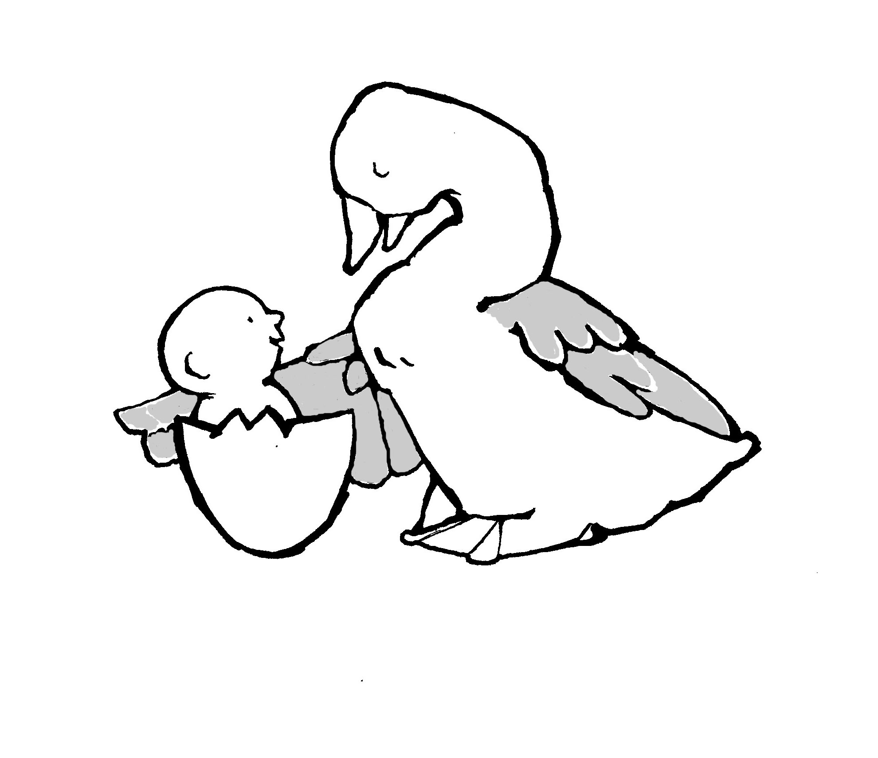
Parent-Child Mother Goose Program®
Programme la Mère l”Oie pour parents et enfants®

To reduce paper and postage we ask that you email this form to: info@nationalpcmgp.ca Just save your completed form to your computer in Word format and attach to an email with subject heading: Certification Registration Form.
You may also mail the form to National Parent-Child Mother Goose Program® Office: 213, #200 – 5700 Yonge Street, North York, Ontario, M2M 4K2.
Other forms and information may be found at our website at: http://nationalpcmgp.ca/

Teacher Certification Registration Form

Welcome! Please send this information to us at the office to help us keep up-to-date and to assist us in planning for your professional development and certification. Thank you.

Agency/Organisation Name

Mailing Address

City/Town | Province | Postal Code
Phone | Fax | E Mail
Contact person(s)

This organisation is a member in good standing for this calendar year Yes No
This organisation has been sending program reports to the National Office Yes No

Please fill out only one of the sections below: either Apprenticeship or Self-Evaluation
If you are unsure of which applies to you, please refer to the Training and Certification for P-CMGP Teachers document available on our website http://nationalpcmgp.ca/ or by contacting the office.

Self-Evaluation Registration

Name of Self-Evaluation Teacher

Name(s) of Co-teacher(s)

Date of this registration form Date of Teacher Training Workshop

Apprenticeship Registration

For Apprenticeship Registration to be complete, in addition to this form, the Apprenticeship Commitments and Training Teacher Information Form needs to be filled out and sent to the National Office. This form is available on our website http://nationalpcmgp.ca/ or by contacting the office.

Name of Apprentice Teacher

Name of Training Teacher

Date of this registration form Date of Teacher Training Workshop

