Your MEMBERSHIP and DONATIONS are crucial to keeping the National Parent-Child Mother Goose Program® strong!

With your help, we’re able to continue providing leadership, advocacy, and fostering connections for the P-CMGP in Canada. It is our goal to see Parent-Child Mother Goose programs available in communities in every province and territory – and we’re getting closer to that goal every year! Parent-Child Mother Goose programs help parents gain skills and confidence, enabling them to create positive family patterns during their children’s crucial early years.

Become a MEMBER of the National Parent-Child Mother Goose Program®, because:
- A strong membership demonstrates that our work has community support
- As an informed member, you can become a voice for the program
- Your questions and comments can help us to develop our resources, programs and our outreach

As a member in good standing with the Parent-Child Mother Goose Program®, you will receive:
- Electronic newsletters
- Permission to use the trademarked logo in your own publications
- Permission to photocopy newsletters, songs, rhymes to share with your own program facilitators
- Results of research and professional studies of the program
- An invitation to the Annual General Meeting each Fall
- Notification of new resources and training available to enhance your own Parent-Child Mother Goose Program®
- Promotion of your own P-CMGP on our website to help parents find you!
- Available upon request: we can send you electronic copies of the P-CMGP brochure or other promotional materials to assist you with promotion of your own program

Thank you for your support!

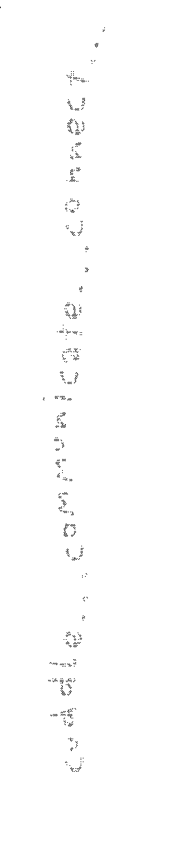

National Parent-Child Mother Goose Program®
www.nationalpcmgp.ca | info@nationalpcmgp.ca
Office 213, #200 – 5700 Yonge Street | North York, Ontario, Canada | M2M 4K2

Membership and Donation Form
Please fill out the following information and send in by mail or email.
Agency memberships are $100.00, and Individual Memberships are $40.00 per year.

Date:___________________________________________

Membership Information

Type of membership: ____ Individual _____ Agency
Name: ________________________________________________________________________
Agency: _______________________________________________________________________ Contact Person:_________________________________________________________________
Mailing Address: ________________________________________________________________
City/Town: _______________________ Prov/Terr:___________ Postal Code: ______________
Country: ____________Phone: _________________ E-mail: ____________________________
Would you like your agency listed on our National Website, under our ‘Program Listings’ page? Y _____ N _____
The Parent-Child Mother Goose Program® is a not-for-profit charitable organization.
Donations are vital to our ability to deliver and develop the program.
You will receive a tax-deductible receipt for your donation.
Charitable Registration Number 859460842 RR0001

Payment Details
Enclosed are funds for,
- Annual Agency Membership Fee of $100.00 $ ____________
- Annual Individual Membership Fee of $40.00 $ ____________
- A Donation, in the amount of… $ ____________
  - Total payment amount: $ ____________
Please indicate method of payment:
Cheque, made out to the National Parent-Child Mother Goose Program®
E-Transfer (info@nationalpcmgp.ca)
CanadaHelps.org
https://www.canadahelps.org/en/charities/parent-child-mother-goose-program-programme-la-mere-loie-pour-parents-et-enfa/
PLEASE ALSO COMPLETE PAGE TWO IF PURCHASING AN AGENCY MEMBERSHIP.
National Parent-Child Mother Goose Program®
www.nationalpcmgp.ca | info@nationalpcmgp.ca
Office 213, #200 – 5700 Yonge Street | North York, Ontario, Canada | M2M 4K2

Please list your current P-CMG Facilitators/Animators/Teachers

Name | Agency | Email Address

